Beagle Smalltalk Overview
  - David Buck

Introduction
Beagle Smalltalk is an implementation of the Smalltalk programming language. Smalltalk is a dynamic programming language that lets you explore ideas without long waits to compile or run your code.

Launching Beagle Smalltalk
In Windows, launch:
StartupBeagleSmalltalk.bat

In Linux, open a shell and cd to the BeagleSmalltalk directory. From there, run:
./beagle beagle.im
Then open the web browser on BeagleUI.html

If it’s successful, you’ll see something like this:
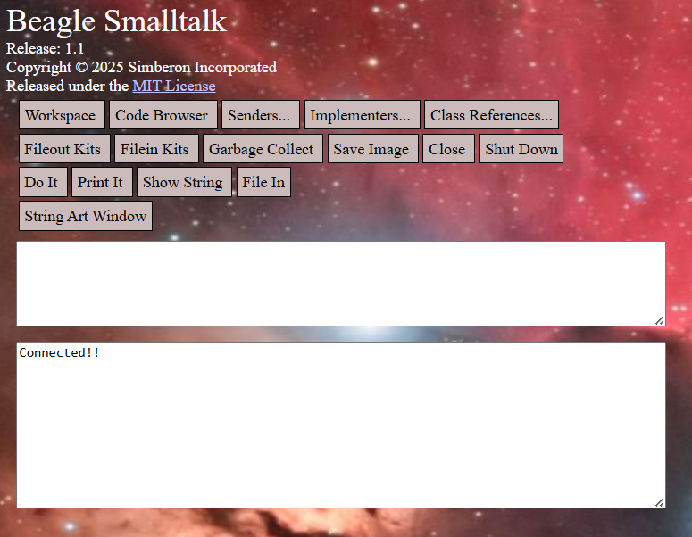
The message “Connected!!” means that Smalltalk is running.

The Screen Buttons
The buttons on the screen allow quick access to Smalltalk tools and to low-level tools that can be used if the window-based tools don’t work or are inappropriate.

Workspace
The Workspace button opens the Workspace window. The workspace is a window that allows you to execute Smalltalk code. You can select text in the workspace and use the pop-up menu to execute the code.
- Do It – run the selected text without printing the result
- Print It – run the selected text and print the result in the workspace
- Inspect It – run the selected text and open the inspector on the result
- Debug It – run the selected text with a halt to open the debugger before the code starts
- Load… prompts for a text file to load into the workspace
- Save… saves the contents of the workspace into a text file
- Rename Workspace… changes the text in the title bar of the workspace window
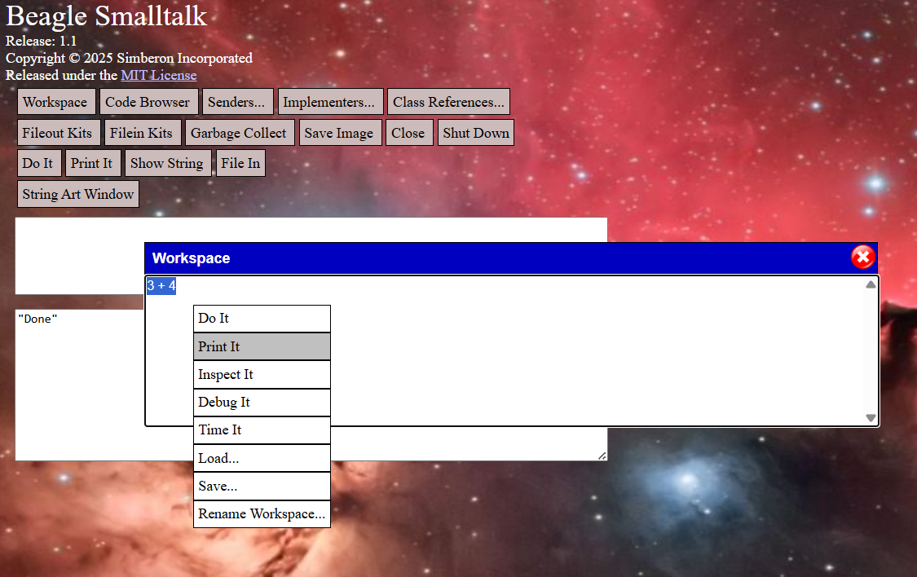

Code Browser
The Code Browser is a window that can show you Smalltalk code stored in the system and allows you to change and add code. The top of the browser has four panes.
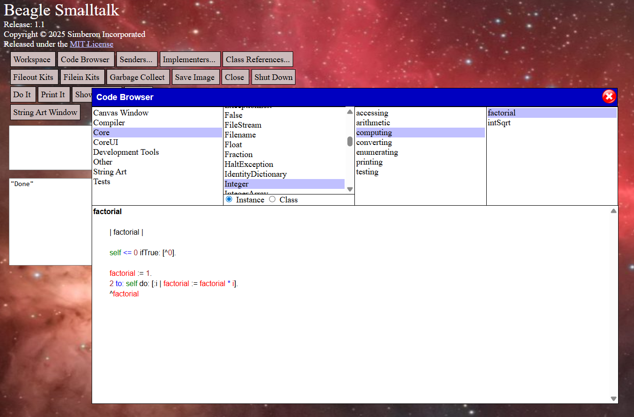
- Kits
  - The first pane shows kits. Kits are groupings of code that contain classes and extension methods of other classes. A kit can require other kits which must be loaded before this one can be loaded.
- Classes
  - The second pane shows classes. Classes represent object types such as Integer or String.
- Protocols
  - The third pane shows method protocols. A protocol is just a convenient named grouping of methods to allow you to quickly find methods.
- Methods
  - Methods are the actual Smalltalk code associated with classes.
The text pane at the bottom of the browser shows the Smalltalk code of the selected method.

Senders…
The Senders button prompts for the name of a method and opens a browser on all methods that send a message with that name.

Implementers…
The Implementers button prompts for the name of a method and opens a browser on all methods with that name.

Class References…
The Class References button prompts for the name of a class and opens a browser on all methods that reference that class.

Fileout Kits
Fileout Kits writes code for all kits into files in the kit folder.

Filein Kits
Load the kits from the kits folder.

Garbage Collect
Perform a global garbage collection.

Save Image
Overwrite the beagle.im file with a snapshot of the current Smalltalk environment. This operation will first close all windows.

Close
Close the connection to the image but keep the image running.

Shut Down
Shutdown the image.

Do It
Do It is a tool that helps if the regular user interface isn’t working for some reason. It allows you to type Smalltalk code in the upper text box and execute it.

Print It
Print It allows you to type Smalltalk code in the upper text box and execute it showing the result in the lower text box.

Show String
Show String is the same as Print It except that it prints the plain string instead of a quoted string if the result is a string.

File In
File In allows you to enter text in the upper text box which it will compile and load into the Smalltalk image. This is handy if your Smalltalk crashes and you want to recover your changes from the beagle.cha file. Scroll to the bottom then search backwards for “saveImage”. Everything afterward is code you changed since the last save.
For methods, copy from the line that says “methodsFor:” to the end of the method including two ! symbols. For example,
! TestcaseWindow methodsFor: 'updating' !
allTestcases

| collection |

collection := OrderedCollection new.
self suites do: [:eachSuite | collection addAll: eachSuite allTestcases].
^collection
! !
Paste this into the top text area and press File In to load that method into Smalltalk.

For classes, take the class definition and add a ! at the end
Testcase subclassNamed: #ObjectTests
instVarNames: #()
classVarNames: #()
classInstVarNames: #()
environment: Object systemDictionary
kitName: 'Tests' !

Again, paste this into the upper text area and press File In.

